

Mangatawhiri School Newsletter 2020



**Responsibility ~ Haepapa, Respect ~ Whakaute, Resilience ~ Aumangea It’s the Mangatawhiri Way**

# “In life we learn In school we nurture the spirit for life” STRIVE ON

30th November 2020

Dear Parents & Community Members,

Kia Ora Koutou Katoa,

It was nice to have time over the weekend to recharge and regroup after a very hectic week where we enjoyed having quality time with you and your children reflecting on the year and celebrating just what we have all achieved in 2020. We also celebrated with Jess Dearlove and her family on her graduation as a fully registered teacher (she can now take off her training wheels) and then we had a fabulous disco on Friday. Big Thanks to Mr Heta for his DJ skills and awesome lights!



This week is just as hectic as we put the finishing touches to our Xmas on the Field extravaganza! Remember to RSVP if you would like sausages cooked for your family to enjoy with your picnic tea (and yes you can bring some tasty drinks to enjoy too!).

Unfortunately, our staff continue to experience sadness around them. Our thoughts are with Jean Carson on the passing of her mum, Merrylle Millar on the passing of a very good friend and Tracey Weight on the passing of a well-loved Uncle.

Our school pool is not well. Mr Adams spent many, many hours on the weekend working hard to remedy a bug that was in the water and resistant to chemical treatment. Mr Adams drained the pool, water blasted it and has started to refill it. We cannot express how grateful we are to Mr Adams for all his work and effort in getting the pool summer ready. You are a champion Mr Adams!

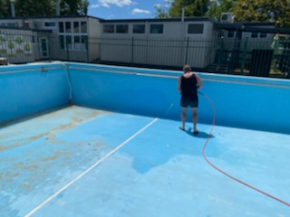

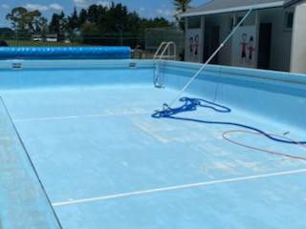We will begin to sell pool keys to the community but please note the pool is NOT open yet. We will confirm when the pool is safe and ready for swimming.

***Sharron Scouse***

***PRINCIPAL***

20191024_125201 (1) ******

****

* ***Parents & Families*** who joined us at assembly
* ***AFFCO Bobby Calves Cash for School’s Farms ~ Powar Farm, Bythell Farm, Kopuera Dairies***
* ***Varga Family*** for the wonderfulgift box of goodies & kind words for staff
* ***Everett Family*** for the delicious goodies & kind words for staff
* ***Mr Adams*** for all his work on our school pool
* ***Noel Linton*** for the beautiful roses
* ***Mr Heta*** for being our awesome DJ at the disco



|  |  |
| --- | --- |
|  | |
| ***Tuesday 1st December:***   * Youthtown Sports * Y7&8 Girls cricket Festival here at Sch * Y8 Mufti for remainder of year * Y1-Y7 – own choice of hat for rest of year – PLEASE NAME | ***Wednesday 2nd December:***   * R7 Technology |
| ***Thursday 3rd December:***   * Year 8 Graduation Day & Dinner | ***Friday 4th December:***   * Fun day Friday: Christmas * 6pm Xmas on the Field Evening |
| ***Monday 7th December:***   * 6pm BOT, Staff & Community Meeting | ***Tuesday 8th December:***   * Whole School Big day Out |
| ***Wednesday 9th December:***   * ***6pm Junior Prize giving in hall*** | ***Thursday 10th December:***   * ***6pm Senior Prize giving in hall*** |
| ***Monday 14th December:***   * Last day of term 4 School finishes at 2.30pm | ***Tuesday 15th December:***   * ***TEACHER ONLY DAY*** |



****STUDENTS OF THE WEEK:** **

Room 1: ***Tyla Brears***

Always giving 100% in all areas of her learning

Hub: ***Jackson Picard***

Fabulous progress in reading

***Bronte Peter***

All round positiveness & great work habits

Room 4: ***Nirvana Forder***

Great leadership & organisation skills

Room 5: ***Ella Price***

Big improvement in home learning responsibility

Room 6: ***Flynn Powar***

Taking responsibility for his learning especially in

maths

Room 7: ***Hunter Ramsay***

Respect, resilience & sense of humour

Room 8:***Lyla Roberts***

Consistently showing The Mangatawhiri Way

****SCHOOL AWARDS:** **

Class Award: ***Rooms 1,7&8***

Great ideas with their art & baking

Sports Award: ***Kacey Soppet, Azayleia Hughes,***

***Jordan Johnston***

Qualifying for Auckland Athletic Champs

*Guitar* Award: ***Ashton Soppet***

Extra effort in learning new techniques

*Staff* Award: ***Mrs Weight***

Going the extra mile for our school garden

*Parent* Award: ***Mrs Mullaly***

Super help in the office

***Mrs Braid***

Sharing her singing skills with our choir

*Mangatawhiri Way* Award: ***Andrea McMeekan***

Fabulous support in so many ways

*Clean Class* Award: ***Fletcher Grant***

MC900134537[1]**BEST BUS PEOPLE:** MC900134537[1]

***Willow Vennell***



**MANGATAWHIRI WAY:**

**1st Kauri ~ 330** points **2nd Manuka ~ 230** points

**3rd = Tanekaha & Rimu 160** points

**HOUSE PEOPLE OF THE WEEK:** ****

**KAURI:**

***Petra Cordes***

**MANUKA:**

***Jesse Freeman***

**RIMU:**

***Kayla Geaney***

**TANEKAHA:**

***Hana Burns***

******

**HOUSE POINTS:**

***WEEK 7:***

***1st Kauri ~ 245*** *points* ***2nd Tanekaha ~ 233*** *points*

***3rd Rimu ~ 224*** *points* ***4th Manuka ~ 190*** *points*

***TERM 4:***

***1st Kauri ~ 511*** *points* ***2nd Tanekaha ~ 466*** *points*

***3rd Manuka ~ 433*** *points* ***4th Rimu ~ 391*** *points*

*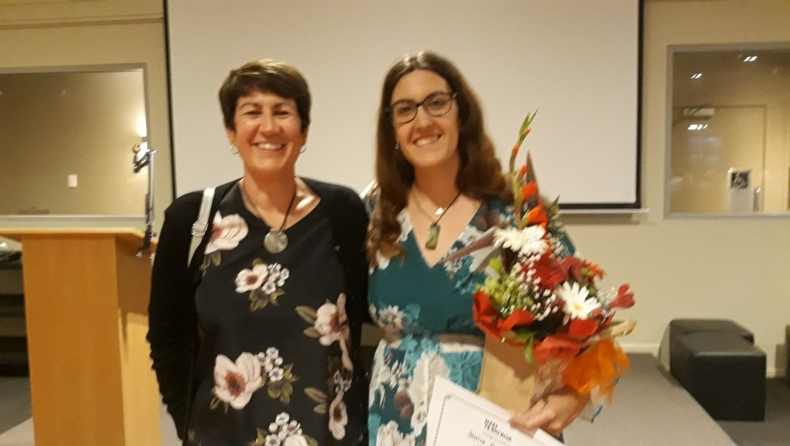*

***Miss Dearlove & her mum celebrates her teacher registration graduation***

***DISCO Highlights***



Best Helpers to set up: ***Andrea McMeekan, Brooke McMeekan, Mia Caskie, Leo Lupeiki, Summer Lupeiki***

Best Dressed Boy: ***Leo Lupeiki***

Best Dressed Girl: ***Arisha Ram***

Best Dancer on the floor: ***Hailey Dalton***

Best Limbo: ***Mackenzie Basevi &***

***Sofia Styles***

Best House Leader Help: ***Holly Timmins***

Best Staff Help: ***Mrs Schu, Mrs Dodds, Mrs McKinstry, Miss Davis, Mrs Ormsby***

Best Ex Pupil Help: ***Courtney McKinstry &***

***Jaela Tawhiti***

Best DJ: ***Mr Heta***

Best Parent Helpers: ***Mrs Tawhiti,***

***Mrs Grant, Mrs Richards***

Best Taxi Driver: ***Mrs Schu***

**2021 SCHOOL DATES CONFIRMED**



**Term 1** Wednesday 3rd February ~ Friday 16th April

**Term 2** Monday 3rd May ~ Friday 9th July

**Term 3** Monday 26th July ~ Friday 1st October

**Term 4** Monday 18th October ~ Tuesday 14th December

***2021 STAFFING***

We can confirm the following for staffing and classes for 2021:

Room 1 – Year 1 ~ ***Cheryl McKinstry***

Room 1 – Year 2 ~ ***Lorelle Dodds***

Room 4 – Year 2&3 ~ ***Tracey Schumacher &***

***Sue Young***

Room 2 – Year 3&4 ~ ***Marilyn Millar***

Room 3 – Year 3&4 ~ ***Kendall Spence***

Room 5 – Year 5&6 ~ ***Sara Kroef***

Room 6 – Year 5&6 ~ ***Jess Dearlove***

Room 7 – Year 7&8 ~ ***Tracey Weight &***

***Hayley Vujcich***

Room 8 – Year 7&8 ~ ***Laura Biggelaar &***

***Robyn Davis***

Reading Recovery & Teacher Release ~

***Merrylle Millar***

Teacher Release ~ ***Sam McPherson***

Teacher Aides ~ ***Tania Bush &***

***Dawn Walker***

We look forward to welcoming Hayley back into teaching after a break with her family. Hayley is an experienced Year 7&8 teacher. Kendall Spence joins us after completing her teacher training studies and a very successful Year 3&4 placement at Hill School.

On Friday 11th December children will have an opportunity to meet their classmates and teacher for 2021.

******

***XMAS on the Field***

***Friday 4th December***

***THIS WEEK***

***6-7.30pm***

***(Our end of school year performance event)***

***Bring your family along***

***for a family picnic dinner  on the field with entertainment from every class as well as our***

***Kapa Haka & Choir Groups ***

***Sausages will be cooking on the BBQ Please RSVP for catering to Mrs Ormsby***

******

****

***PLANNING FOR SUMMER!***

***WE STILL NEED HELP WITH OUR POOL***

For the pool to be available to the community to use (after school, on weekends and during the summer holidays) we require parents who will take responsibility for a week or two of pool care during the summer season.

~~~~~~~~~~~~~~~~~~~~~~~~~~~~~~~~~~~~~~~~~

**YES:** I am available to assist with pool care during the summer season.

Jan: 18th-24th Jan: 25th–31st Feb: 15th-21st Mar: 8th–14th Mar: 29th-4th

**NAME:** \_\_\_\_\_\_\_\_\_\_\_\_\_\_\_\_\_\_\_\_\_\_\_\_\_\_

**PHONE:** \_\_\_\_\_\_\_\_\_\_\_\_\_\_\_\_\_\_\_\_\_\_\_\_\_

**Please let Mrs Ormsby know URGENTLY**

****

***SCHOOL POOL KEYS ON SALE NOW***

***Families helping with pool care: $60.00***

***Other families: $90.00***

***Community Members: $100.00***

***See Mrs Ormsby***

**OUR LIBRARY IS CLOSED**

**ALL BOOKS MUST BE BACK**

****

Please have a good look for any library books or school readers and return to school URGENTLY.

Invoices for unreturned library books will be sent home on Monday 7th December

Hall of fame

**EMILY McHARDY**

**2019-2020**

***Outstanding Dancer***  
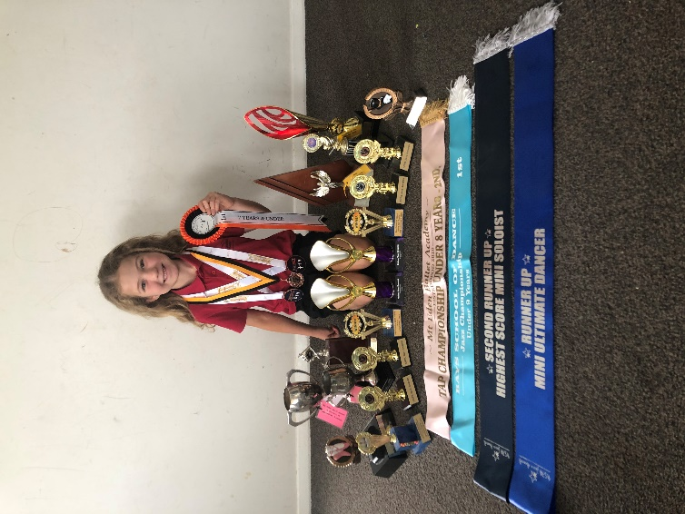

***A very talented and gifted young dancer, Emily Mchardy is on a winning streak in 2020! Emily is our youngest entrant on our hall of fame wall.***



***The Board of Trustees and Staff of Mangatawhiri School invite our parents to a community feedback meeting on***

***Monday 7th December***

***6pm-7pm in***

***Room 4***

*Staff and BOT will share highlights of our school year*

*A family movie will play in Room 1 for childcare if needed*

***Please RSVP to Mrs Ormsby for catering & childcare***

**OUR SCHOOL BIG DAY OUT**

**Tuesday 8th December**

****

As we were unable to enjoy our school camp this year (we have rebooked for next year) we have arranged a school big day out on Tuesday 8th December.

* Rooms 1,2,3 will be visiting Butterfly Creek 
* Rooms 4,5,6 will be visiting Treasure island Mini Golf 
* Rooms 7&8 will be visiting Rocket Ropes 

We will all be travelling by buses and meet back at the Botanical Gardens in Manurewa for a late lunch.

Cost for this day is $10 per child with a maximum of $20 per family (i.e. 1 x child $10, 2 x children $20, 3 or more children $20)

If your child will not be joining in this activity, we ask that you keep your child at home on this day as there will be no staff at school to supervise.

Please make payment through internet banking or pay cash to Mrs Ormsby

---------------------------------------------------------------------------------

My child \_\_\_\_\_\_\_\_\_\_\_\_\_\_\_\_\_\_\_\_\_\_\_\_\_\_\_\_\_\_\_\_\_\_\_ will be attending the BIG DAY OUT on Tuesday 8th December

I give permission for them to travel by bus

Enclosed payment / Internet banking

ASB: 123 078 0092594 00

Signed: \_\_\_\_\_\_\_\_\_\_\_\_\_\_\_\_\_\_\_\_\_\_\_\_\_\_\_\_\_\_\_\_\_\_\_\_\_\_\_



**We have 2+ buckets FULL of lost property**

**Including one large bucket of shoes**

**PLEASE CHECK**



It is nearly time to say farewell to our 2020 Year 8 students.

**Matthew , Josiah , Jared , Denver , Ryan , Joshua ,**

**Kate 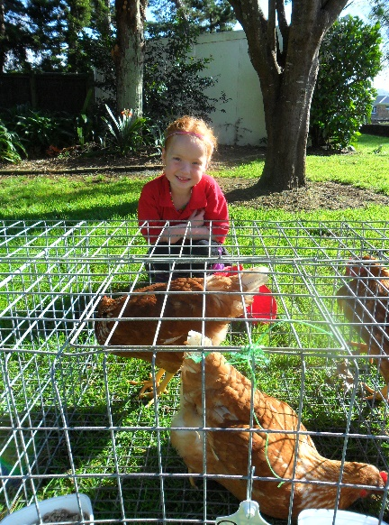, Rory ,Paige ,**

**Azayleia , Ruby , Chase ,**

**Kyan , Jordan , Connor 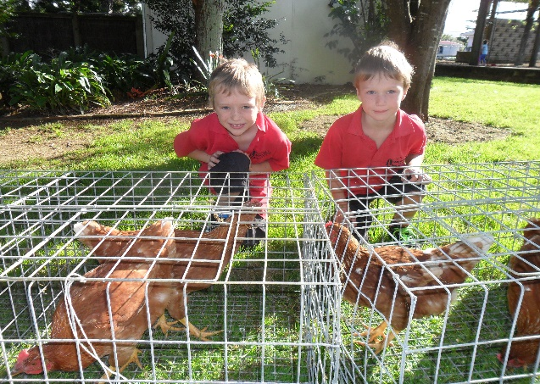, Michael , Zaryke , Martie , Kayla , Emma , Cheyann ,**

**Amber  Holly ****



**This week we look forward to a fun day out at Rainbows End and dinner to celebrate the end of their primary schooling.**



**Cookies SOLD OUT**

****

**Chips or Popcorn Packet 50C at morning tea**

**Limited number**



**Ice blocks 50c at lunchtime**

****

**ROOM 1 CUP CAKE SALE**

**Order & Pay TOMORROW (Tuesday) at the office**



Mangatawhiri School

**ENROLEMENT ZONE**

Due to the recent growth we have experienced and the need for 2 more classrooms (which will be arriving in March), the Ministry of Education has enforced an enrolment zone which will come into effect from Monday 3rd May 2021. A written description of the zone is attached.

If you live outside our boundary zone and have a child currently enrolled at Mangatawhiri School and have a sibling due to start anytime from Monday 3rd May 2021 onwards, you must register for a ballot. The Board of Trustees will determine if or how many vacancies are available each term. Siblings of students currently enrolled will have priority on the ballot criteria.

This is all a new process for us and while we understand the reasons behind the decision it will make things tricky in the short term. Please make a time to chat with me if you would like any further information in regard to our zone.

******



Complete fun activity challenges and be in to win prizes! **The programme will be held 11 January to 20th February 2021 Conta~~c~~t your local library for more details**

****



***ONLINE SAFETY INFORMATION EVENING***

***TUESDAY 8TH DECEMBER***

***6.30PM - 8PM***

******

***MARAMARUA RUGBY CLUB ROOMS,***

***2222 STATE HIGHWAY 2***

